October 26, 2017
2016 Census: Housing, Immigration and Ethnocultural Diversity, Aboriginal peoples
The 2016 Census Day was May 10, 2016. On October 25, 2017, Statistics Canada released data on the topics of Immigration and Ethnocultural Diversity, Housing, and Aboriginal peoples.
Key Points

Housing Affordability
- As a traditional measure of affordability, Statistics Canada and Canada Mortgage Housing Corporation (CMHC) use the percentage of income households spend on shelter (including rent, mortgage, taxes, repairs, etc.). If a household spends more than 30 per cent of their before-tax income on shelter costs, they are considered to be experiencing affordability issues. According to the 2016 Census, 245,605 renter households fall into this category. This represents 46.7 per cent of all renter households in Toronto, which corresponds to the GTHA average. (See Table 2: Shelter Cost to Income Ratio, Toronto, Rest of the GTHA and GTHA, 2006 and 2016 and Table 3: Shelter Cost to Income Ratio, Toronto, GTHA Municipalities, 2006 and 2016)
- In 2016, Toronto was home to two out of three GTHA renter households spending 30 per cent or more of their income on rent. Affordability rates among renter households have remained relatively constant over the past 10 years, dropping very slightly from 47 per cent in 2006. This rate has increased in the rest of the GTHA over the decade.
- There were 160,465 owner households that spent 30 per cent or more on shelter costs. This represents 27.3 per cent of Toronto owners experiencing affordability issues, which is higher than in the GTHA (25.0 per cent) but slightly lower than the rate for Toronto in 2006 (27.7 per cent).

Dwelling Units and Tenure
- In 2016, there were 1,112,930 private households in Toronto. Of these, 587,095 households or 53 per cent owned their home, while 525,835 or 47 per cent rented. This proportion of renters is higher, as compared to 33 per cent in the GTHA, overall. Ownership rates in the City of Toronto declined by 1 per cent from 54 per cent in 2006 to 53 per cent in 2016. (See Table 4: Total Private Households by Tenure, Toronto, GTHA and Rest of the GTHA, 2006 and 2016 and Figure 6: Total Private Households by Tenure, Toronto, 1971 to 2016)
- 292,265 (26 per cent) of occupied private dwellings in Toronto were condominiums, compared to 14 per cent in the rest of the GTHA. (See Table 5: Total Private Households by Condominium Status, Toronto, GTHA and Rest of the GTHA, 2016)
- 50 per cent of occupied private dwellings in Toronto had one to four rooms, higher than the following regions: Hamilton (25 per cent), Peel (24 per cent), York (17 per cent), Halton (16 per cent) and Durham (14 per cent). Across the GTHA, the top three municipalities that had occupied private dwellings with eight or more rooms were Halton (41 per cent), York (40 per cent) and Durham (40 per cent), compared to Toronto at 17 per cent.
- In Toronto, zero and one-bedroom dwelling units accounted for 30 per cent of the total number of occupied private dwellings, followed by two-bedroom units (28 per cent), three-bedroom units (24 per cent) and units with four or more bedrooms (17 per cent). The percentage of dwelling units with zero or one bedrooms was the highest in Toronto compared to GTHA (18 per cent) due to continuing trends in the high volume of condominium development in Toronto where unit sizes tend to be smaller than in the past. (See Table 7: Total Private Households by Number of Bedrooms, Toronto, GTHA and Rest of the GTHA, 2006 and 2016)
- In the last five years, 80,805 occupied dwelling units were added to the City of Toronto housing stock. This represents 41 per cent of all GTHA occupied dwelling units constructed since 2011. The increase in occupied dwelling units over the last five years is comparable to the completed housing reported by CMHC and built residential units recorded by the City of Toronto over a similar period. (See Table 8: Total Private Households by Period of Construction, Toronto, GTHA and Rest of the GTHA, 2016)
- In 2016, over a quarter of the rented households are maintained by a person aged 25-34 years (26 per cent). The same age group accounts for 10 per cent of ownership in the City of Toronto. (See Table 9: Total Private Households by Tenure by Age of Primary Household Maintainer, Toronto, 2016 for Toronto data and Figure 7: Age of Primary Household Maintainer by Tenure and the GTHA Municipalities, 2016 for a graphic illustrating Tenure by Age of Primary Household Maintainer for Toronto and the GTHA municipalities.)

Value of Dwelling
- In 2016, Toronto homeowners reported an average dwelling value of $754,015, compared to $506,409 for Ontario. Within the GTHA, York Region homeowners reported the highest average value at $871,831. In Toronto, the average value reported for an apartment in a building greater than five stories of $430,334 was less than half that reported for a single-detached house, at $996,136. (see Figure 8: Average Dwelling Value Reported by Homeowners in the GTHA, 2016).

Citizenship
- The number of people living in Toronto that are not Canadian citizens is greater than anywhere else in the country. According to the Census, 395,300 people living in Toronto are not Canadian citizens (14.7 per cent of the population).
- In 2016, 85.3 per cent of people living in Toronto were Canadian citizens, compared to 90.9 per cent in the rest of the GTHA and 93.0 per cent for all of Canada.
- Citizenship rates in Toronto increased slightly from 2006, when 84.7 per cent of Toronto residents held Canadian citizenship. This is in contrast to the national trend, where the citizenship rate dropped from the 2006 rate of 94.4 per cent.

Immigration
- Statistics Canada uses the term immigrant to refer "to a person who is, or who has ever been, a landed immigrant or permanent resident. Such a person has been granted the right to live in Canada permanently by immigration authorities. Immigrants who have obtained Canadian citizenship by naturalization are included in this group." (Statistics Canada, 2017) The use of the term immigrant throughout this backgrounder refers to this definition and does not include non-permanent residents such as refugee claimants and people from other countries in Canada on work or study permits.
- In Toronto in 2016, 1,332,090 residents were born in Canada, representing 49.5 per cent of the total population. The data shows 1,266,005 or 47.0 per cent of the population were immigrants. Among GTHA regional and single-tier municipalities, only Peel Region has a higher proportion of immigrants, at 53.2 per cent of the population. These rates are much higher than the national rate, where the 7,540,830 immigrants in Canada represent 21.9 per cent of the population. The remaining 3.5 per cent of Toronto's population were non-permanent residents.
- While Toronto has 7.8 per cent of Canada's population, it has 18.5 per cent of Canada's non-permanent residents.
- More immigrants are female. While 50.0 per cent of Canadian-born city of Toronto residents are female, 53.9 per cent of immigrants living in Toronto are female. Similar but slightly less pronounced male to female ratios are found among immigrants in the rest of the GTHA (53.0 per cent female) and Canada (52.4 per cent).

Period of Immigration
- Of the 1,266,005 immigrants living in Toronto in 2016, 187,945, or 14.8 per cent were recent immigrants, having landed in Canada in the previous five years (from 2011 to May, 2016). This is a higher proportion of recent immigrants than seen in the rest of the GTHA, where 11.4 per cent of the immigrant population had landed in the last five years. However, these rates are lower than the national figure, where recent immigrants made up 16.1 per cent of all immigrants in Canada. (see Figure 1: Immigrant population by period of immigration, 2016)
- This represents a shift from the pattern in 2006. In the 2006 Census, Toronto was home to 267,855 recent immigrants (immigrants who landed between 2001 and 2006), and made up 21.6 per cent of Toronto's immigrant population. Comparatively, recent immigrants made up 17.9 per cent of Canada's immigrant population. Recent immigrants made up a much larger share of Toronto's immigrant population in 2006, but only a slightly larger share of Canada's immigrant population.
- Expressed as a proportion of the total population, recent immigrants comprised 3.6 per cent of Canada's population in 2006 and 3.5 per cent in 2016. For Toronto, the proportion dropped from 10.8 per cent of the population in 2006 to 7.0 per cent in 2016. This decreasing trend was also mirrored in every GTHA upper- or single-tier municipality, with the exception of Halton, which saw recent immigrants grow from 3.0 to 3.8 per cent of the total population.
- Toronto is home to the largest number of recent immigrants of any Canadian city. In 2016, Toronto was home to 17.5 per cent of all recent immigrants to Canada, while Toronto comprises 7.8 per cent of the country's population.
- Both Toronto and the rest of the GTHA showed a higher concentration of immigrants who landed in Canada from 2001 to 2005, from 1991 to 2000, and from 1981 to 1990. (see Figure 1: Immigrant population by period of immigration, 2016)

Age at Immigration
- More of Toronto's immigrant population were 25-years-old or older when they immigrated to Canada (54.7 per cent), compared to the rest of the GTHA (50.9 per cent) or nationally (51.6 per cent). (See Figure 2 Immigrant population by age at immigration, 2016)

Immigration Admission Category
- For the first time, the Census provided data on the category of admission for immigrants with permanent resident status. This data is available for immigrants who landed from 1980 to the day of the Census, May 10, 2016. In Toronto, 988,325 residents are people who immigrated to Canada after 1980. Of this group, 48.1 per cent were admitted under the economic category, 32.5 per cent were sponsored by family, 17.8 per cent landed as refugees, and 1.6 per cent were in other immigration categories. This is a somewhat higher proportion of refugees than for Canada (15.1 per cent), and a somewhat lower proportion of economic immigrants than for Canada (52.5 per cent). (see Figure 3: Immigrant population by admission category)
- For maps of immigrants who were admitted in the categories of refugees and economic immigrants, see Map 3 Population of immigrants admitted as refugees (1980-2016), Toronto 2016; Map 4 Population of immigrants admitted as refugees (1980-2016), GTHA municipalities, 2016; Map 5 Population of immigrants admitted as economic immigrants (1980-2016), Toronto 2016; and Map 6 Population of immigrants admitted as economic immigrants (1980-2016), GTHA municipalities, 2016.

Place of Birth
- More than half (53.5 per cent) or 737,490 people living in Toronto in 2016 who were born outside of Canada came from countries in Asia. The figures are even higher in York Region (64.5 per cent) and Peel Region (59.6 per cent), which bring the average for the rest of the GTHA up to 55.1 per cent. Immigrants from Asian countries made up 48.0 of all immigrants across Canada.
- Of recent immigrants who resided in Toronto in 2016, 129,695 or 69.0 per cent were born in Asian countries. The top three individual countries of birth were the Philippines (31,730 or 16.9 per cent of all recent immigrants in Toronto), China (23,200 or 12.3 per cent), and India (20,095 or 10.7 per cent). Recent immigrants from European countries totalled 20,265; African countries, 13,300; countries in the Americas, 23,840; and countries in Oceania, 845. (For top 20 countries, see Table 1: Top 25 Birth countries for all and recent immigrants in Toronto, 2016)
- Among immigrants from Asian countries, there has been a shift in the main places of birth. Between 2001 and 2005, 37,330 Toronto residents identified as being born in countries in Eastern Asia, whereas only 17,090 identified their place of birth as being in Southeast Asia. This has reversed for the years 2011 to 2016, with 28,050 (24.9 per cent decrease) identifying Eastern Asia and 34,515 with Southeast Asia (102.0 per cent increase).

Generation Status
- Another way to understand immigrant patterns is through generation status. In Toronto in 2016, 51.2 per cent of the population was born outside of Canada, and are thus first generation status or non-permanent residents. 27.5 per cent of the population was born in Canada and had at least one parent born outside of Canada and are thus second generation, and 21.3 per cent of the population were born in Canada to parents who were both also born in Canada, and are thus third generation or later. (see Figure 4: Generation status, 2016)

Ethnic Origin
- The Census also asked Canadians about their ethnic and cultural ancestry. Respondents were able to identify with up to 6 ethnic origins. Since respondents could provide multiple responses, the number of responses on ethnic origins is greater than the total population.
- Torontonians identify with a wide range of ethnic backgrounds. For instance, 35,630 identified themselves of North American Aboriginal origins, and 345,705 identified with other North American origins. In the Census, 1,288,850 Torontonians identified with European origins; 165,735 with Caribbean origins; 113,815 with Latin, Central and South American origins; 146,870 with African origins; 1,079,290 with Asian origins; and 5,790 with Oceania origins.
- The top five national ethnicities reported by Torontonians were Chinese (332,830), English (331,895), Canadian (323,175), Irish (262,965), and Scottish (256,250).

Visible Minority Groups
- In Toronto, 51.5 per cent or 1,385,855 people belonged to a visible minority group, the first time this figure has surpassed 50 per cent in the city of Toronto. This figure is up from 46.9 per cent in 2006. (see Figure 5 Visible minority groups as per cent of total population, 2016 and Map 7 Proportion of population who are members of a visible minority group, Toronto, 2016)
- Peel Region has the highest visible minority group membership in the GTHA at 62.3 per cent. York Region is comparable to Toronto at 49.2 per cent, but the GTHA excluding Toronto overall has a rate of 43.2 per cent. Across Canada, 22.3 per cent of the population identified as belonging to a visible minority group. (see Map 8: Proportion of population who are members of a visible minority group, GTHA municipalities, 2016)
- The top three visible minority groups in Toronto were: South Asian (12.6 per cent of total 2016 Toronto population), Chinese (11.1 per cent) and Black (8.9 per cent).
- In Toronto, 47,760 people reported belonging to more than one visible minority group. This represents a 53.3 per cent increase over 2006, compared to an 8.7 per cent increase in the total population since 2006.

Aboriginal Peoples
- There were 23,065 people living in Toronto who identified as Aboriginal (0.9% of the total 2016 Toronto population). Of the 23,065 people, 62.3% were First Nations (North American Indian), 31.5% were Métis and 1.2% were Inuk (Inuit). 2.2% reported having multiple Aboriginal identities, and 2.8% reported other Aboriginal identities.
- By comparison, 1.1 per cent of those living in the rest of the GTHA and 4.9 per cent nationally identified as Aboriginal.
- When asked in a separate question about ethnic ancestry, 35,630 Toronto residents identified as having North American Aboriginal ancestry.
- Researchers working with Toronto's Indigenous communities have expressed concern about the ability of the Census to fully enumerate the population of Indigenous peoples living in the city. Statistics Canada also notes that "population estimates for concepts such as Aboriginal identity and Registered or Treaty Indian status are influenced by numerous factors. Users should be aware that point estimates and changes over time are influenced by a combination of natural growth, changes to coverage and to measurement, and other factors affecting how people self-identify. It is not possible to quantify the impact these changes have in isolation from each other." (Statistics Canada, 2017b).
- Studies using different research methods to identify the city's Indigenous population have yielded results that suggest the Census figures may under-represent the population. For example, the Our Health Counts Toronto study cited a 2016 Indigenous population in Toronto of 34,000 to 69,000 people (Our Health Counts Toronto, 2016).
GLOSSARY
Statistics Canada maintains a Census Dictionary for the Census of Population, 2016, available online at: http://www12.statcan.gc.ca/census-recensement/2016/ref/dict/
index-eng.cfm. Many of the definitions listed here are those provided by the Census Dictionary, and many more terms associated with the Census can also be found there.

- Aboriginal identity refers to those persons who reported belonging to at least one Aboriginal group; that is, North American Indian, Métis or Inuit, and/or those who reported being a Treaty Indian or a Registered Indian, as defined by the Indian Act of Canada, and/or those who reported they were members of an Indian band or First Nation.
- Admission category refers to the name of the immigration program or group of programs under which an immigrant has been granted for the first time the right to live in Canada permanently by immigration authorities.
- Census Metropolitan Area (CMA): one or more adjacent municipalities centred on a core population centre. To be included in a CMA, the adjacent municipalities must have a high degree of integration with the core. Integration is measured by commuting flows.
- Census Tract (CT): a small, geographic area, typically with a population smaller than 10,000 persons. Their geography is relatively stable over time to allow for comparison of changes from Census to Census.
- Centre is as defined in the City of Toronto Official Plan. Centres play an important role in how the City manages growth. The Scarborough, North York, Etobicoke and Yonge-Eglinton Centres are places with excellent transit accessibility where jobs, housing and services will be concentrated in dynamic mixed use settings with different levels of activity and intensity. More information can be found in the Toronto Official Plan.
- Dwelling is defined as a set of living quarters. Collective dwellings are institutional, communal or commercial in nature. A private dwelling is a separate set of living quarters with a private entrance either from outside the building or from a common hall, lobby, vestibule or stairway inside the building. The entrance to the dwelling must be one that can be used without passing through the living quarters of some other person(s).
- Economic category immigrant is an immigration admission category which includes immigrants who have been selected for their ability to contribute to Canada’s economy through their ability to meet labour market needs, to own, manage or build a business, to make a substantial investment, to create their own employment or to meet specific provincial or territorial labour market needs.
- Ethnic origin refers to the ethnic or cultural origins of the respondent's ancestors. Respondents are asked to write in any ethnic or cultural origin and may report more than one ethnic origin.
- Generation status refers to whether or not the person or the person's parents were born in Canada. First generation includes persons who were born outside Canada. For the most part, these are people who are now, or once were, immigrants to Canada. Second generation includes persons who were born in Canada and had at least one parent born outside Canada. For the most part, these are the children of immigrants. Third generation or more includes persons who were born in Canada with both parents born in Canada.
- GTHA refers to the Greater Toronto and Hamilton Area. This area is comprised of the single-tier municipalities of Toronto and Hamilton, the regional municipalities of York, Durham, Peel, and Halton, and the cities and towns within the GTHA regional municipalities. This report refers to these single- and upper-tier municipalities as "regions". This is not the same geography as the Toronto Census Metropolitan Area as defined by Statistics Canada.
- Household refers to a person or group of persons who occupy the same dwelling and do not have a usual place of residence elsewhere in Canada or abroad. The dwelling may be either a collective dwelling or a private dwelling. The household may consist of a family group such as a census family, of two or more families sharing a dwelling, of a group of unrelated persons or of a person living alone. Household members who are temporarily absent on reference day are considered part of their usual household.
- Immigrant refers to a person who is, or who has ever been, a landed immigrant or permanent resident. Such a person has been granted the right to live in Canada permanently by immigration authorities. Immigrants who have obtained Canadian citizenship by naturalization are included in this group.
- Immigrant sponsored by family is an immigration admission category which includes immigrants who were sponsored by a Canadian citizen or permanent resident and were granted permanent resident status on the basis of their relationship either as the spouse, partner, parent, grandparent, child or other relative of this sponsor. The terms “family class” or “family reunification” are sometimes used to refer to this category.
- Neighbourhood: The City of Toronto identifies 140 social planning neighbourhoods to help government and community agencies with their local planning. These neighbourhoods allow the provision of socio-economic data at a meaningful geographic area. Not all people define neighbourhoods the same way, but for the purposes of statistical reporting these neighbourhoods were defined based on Statistics Canada census tracts. More information about City of Toronto neighbourhoods can be found on the City's website.
- Period of Construction refers to the period in time during which the building or dwelling was originally constructed, and not the time of any later remodelling, additions or conversions.
- Primary Household Maintainer is the first person in the household listed on the Census questionnaire identified as someone who pays the rent or the mortgage, or the taxes, or the electricity bill, and so on, for the dwelling. In the case of a household where two or more people are listed as household maintainers, the first person listed is chosen as the primary household maintainer. The order in which a person is listed on the questionnaire does not necessarily correspond to the proportion of household payments made by the person.
- Non-permanent resident includes persons from another country who have a work or study permit or who are refugee claimants, and their family members sharing the same permit and living in Canada with them.
- Recent immigrant refers to a person who obtained a landed immigrant or permanent resident status up to five years prior to a given census year. For the 2016 Census, this period is January 1, 2011, to May 10, 2016.
- Refugee is an immigration admission category which refers to immigrants who were granted permanent resident status on the basis of a well-founded fear of returning to their home country. This category includes persons who had a well-founded fear of persecution for reasons of race, religion, nationality, membership in particular social group or for political opinion (Geneva Convention refugees) as well as persons who had been seriously and personally affected by civil war or armed conflict, or have suffered a massive violation of human rights. Some refugees were in Canada when they applied for refugee protection for themselves and their family members (either with them in Canada or abroad). Others were abroad and were referred for resettlement to Canada by the United Nations Refugees Agency, another designated referral organization, or private sponsors.
- Undercoverage is the number of persons excluded by the Census who should have been counted, as determined by Statistics Canada. Although Statistics Canada makes a great effort to count every person, in each Census a notable number of people are left out for a variety of reasons. For example, people may be traveling, some dwellings are hard to find, and some people simply refuse to participate. Overcoverage can also occur, when people are counted more than once or should not have been counted in a given population. Undercoverage is generally more common than overcoverage. The total impact of the coverage errors is the net undercoverage.
- Value of a dwelling: 'Value (owner estimated)' refers to the dollar amount expected by the owner if the asset were to be sold. In the context of a dwelling, it refers to the value of the entire dwelling, including the value of the land it is on and of any other structure, such as a garage, which is on the property. If the dwelling is located in a building which contains several dwellings, or a combination of residential and business premises, all of which the household owns, the value is estimated as a portion of the market value that applies only to the dwelling in which the household resides.
- Visible minority refers whether a person belongs to a visible minority group, as defined by the Employment Equity Act. The Act defines visible minorities as "persons, other than Aboriginal peoples, who are non-Caucasian in race or non-white in colour." Respondents to the Census are asked to select one or more of 12 categories: White, South Asian, Chinese, Black, Filipino, Latin American, Arab, Southeast Asian, West Asian, Korean, Japanese, or Other.
NOTES
All data in this backgrounder are from Statistics Canada, 2016 Census of Population.
Statistics Canada. 2017. Various geographies. Census Profile. 2016 Census. Statistics Canada Catalogue no. 98-316-X2016001. Ottawa. Released October 25, 2017.

All data in this backgrounder are based on geographic boundaries available at time of writing. In the event of any future boundary revisions, some data totals may change. This is especially the case for small area units such as Census Tracts.

The information previously collected by the long-form Census questionnaire was collected in 2011 as part of the voluntary National Household Survey. In 2016, Statistics Canada restored the mandatory long-form Census questionnaire.

FUTURE CENSUS RELEASES
The City of Toronto will be releasing more backgrounders coinciding with each Census release, except for the Census of Agriculture. The Census release schedule is available from Statistics Canada, online at: https://www12.statcan.gc.ca/census-recensement/
index-eng.cfm. Following this release, the City of Toronto will be preparing a backgrounder for one more release:

November 29, 2017 | Education  Labour  Journey to work  Language of work  Mobility and migration

REFERENCES
Our Health Counts Toronto (2016) Interim Report May 2016. Accessed online October 26, 2017 at http://www.welllivinghouse.com/what-we-do/projects/our-health-counts-toronto.

Statistics Canada (2017a), Dictionary, Census of Population, 2016. Accessed online October 26, 2017 at http://www12.statcan.gc.ca/census-recensement/2016/ref/dict/index-eng.cfm.

Statistics Canada (2017b), Aboriginal Peoples Reference Guide, Census of Population, 2016. Accessed online October 26, 2017 at http://www12.statcan.gc.ca/census-recensement/2016/ref/guides/009/98-500-x2016009-eng.cfm.

Prepared by staff from:
- Social Development, Finance and Administration
- City Planning
- Deputy City Manager's Office Cluster A
- Economic Development and Culture
- Employment and Social Services
- Toronto Public Health

Media contact: Olga Lukich, Strategic Communications, 416-392-5349, Olga.Lukich@toronto.ca

Staff contacts:
Housing Data: Michael Wright, City Planning, 416-392-7558, Michael.Wright@toronto.ca
Immigration and ethnocultural diversity; Aboriginal Peoples Data: Harvey Low, Social Development, Finance & Administration, 416-392-8660, Harvey.Low@toronto.ca
Charts and maps

Charts
Figure 1: Immigrant population by period of immigration, 2016 12
Figure 2: Immigrant population by age at immigration, 2016 12
Figure 3: Immigrant population by admission category, 2016 13
Figure 4: Generation status, 2016 13
Figure 5: Visible minority groups as per cent of total population, 2016 15
Figure 6: Total Private Households by Tenure, Toronto, 1971 to 2016 17
Figure 7: Age of Primary Household Maintainer by Tenure and the GTHA Municipalities, 2016 20
Figure 8: Average Dwelling Value Reported by Homeowners in the GTHA, 2016 21

Tables
Table 1: Top 25 Birth countries for all and recent immigrants in Toronto, 2016 14
Table 2: Shelter Cost to Income Ratio, Toronto, Rest of the GTHA and GTHA, 2006 and 2016 16
Table 3: Shelter Cost to Income Ratio, Toronto, GTHA Municipalities, 2006 and 2016 16
Table 4: Total Private Households by Tenure, Toronto, GTHA and Rest of the GTHA, 2006 and 2016 16
Table 5: Total Private Households by Condominium Status, Toronto, GTHA and Rest of the GTHA, 2016 17
Table 6: Total Private Households by Number of Rooms, Toronto, GTHA and Rest of the GTHA, 2006 and 2016 17
Table 7: Total Private Households by Number of Bedrooms, Toronto, GTHA and Rest of the GTHA, 2006 and 2016 18
Table 8: Total Private Households by Period of Construction, Toronto, GTHA and Rest of the GTHA, 2016 18
Table 9: Total Private Households by Tenure by Age of Primary Household Maintainer, Toronto, 2016 19

Maps
Map 1: Dwelling Units Constructed Between 2011 and 2016, Toronto 22
Map 2: Tenant Household Shelter Costs, Toronto, 2016 23
Map 3: Population of immigrants admitted as refugees (1980-2016), Toronto 2016 24
Map 4: Population of immigrants admitted as refugees (1980-2016), GTHA municipalities, 2016 25
Map 5: Population of immigrants admitted as economic immigrants (1980-2016), Toronto 2016 26
Map 6: Population of immigrants admitted as economic immigrants (1980-2016), GTHA municipalities, 2016 27
Map 7: Proportion of population who are members of a visible minority group, Toronto, 2016 28
Map 8: Proportion of population who are members of a visible minority group, GTHA municipalities, 2016 29

Figure 1: Immigrant population by period of immigration, 2016
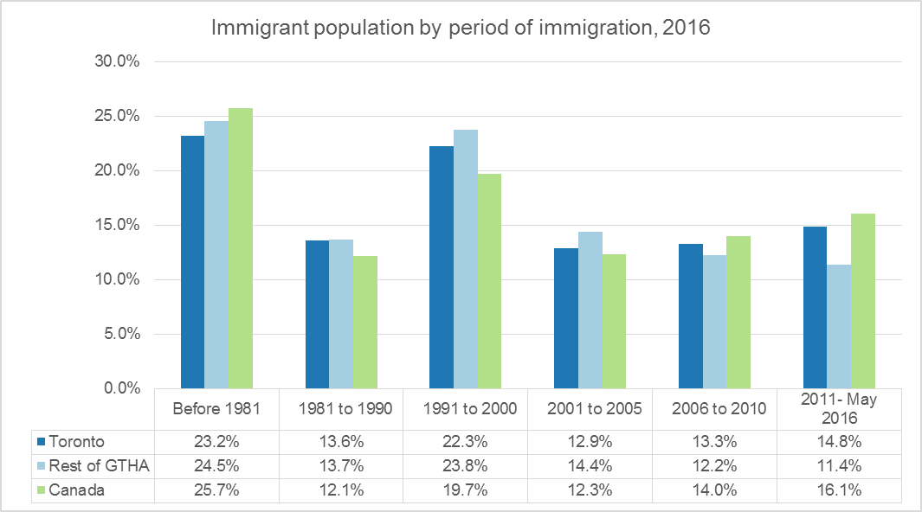

Figure 2: Immigrant population by age at immigration, 2016
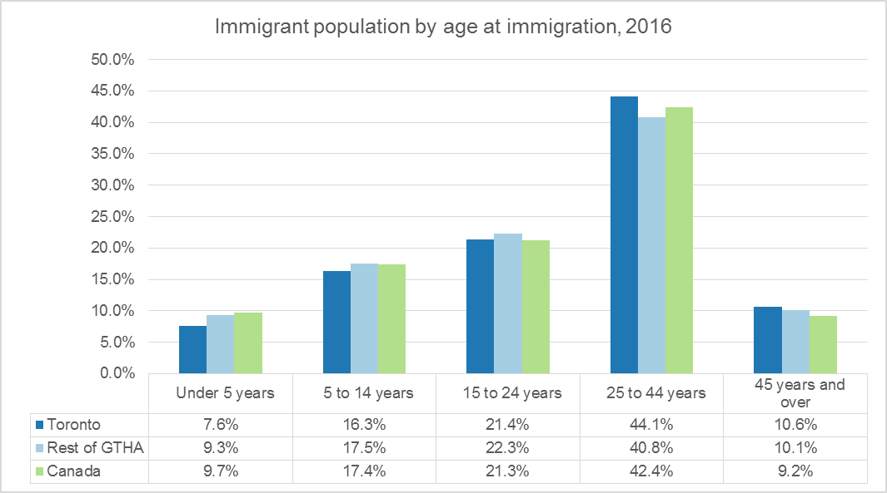

Figure 3: Immigrant population by admission category, 2016
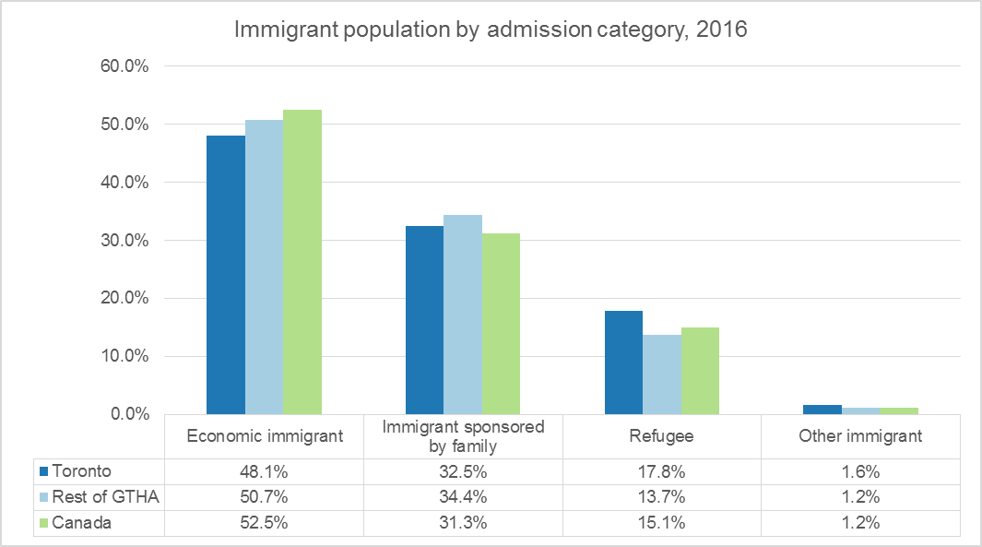

Figure 4: Generation status, 2016
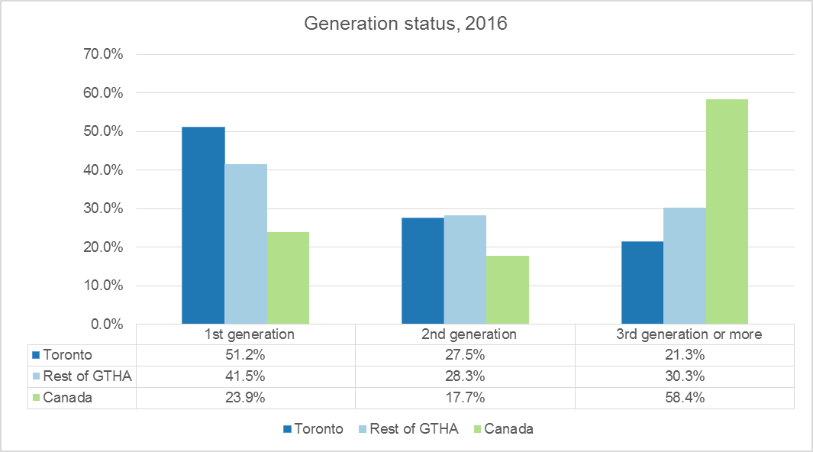

Table 1: Top 25 Birth countries for all and recent immigrants in Toronto, 2016
All immigrants |  | Recent immigrants
Country of birth | Count | Country of birth | Count
China | 131,475 | Philippines | 31,725
Philippines | 118,775 | China | 23,200
India | 79,225 | India | 20,095
Sri Lanka | 52,905 | Iran | 10,935
Italy | 45,515 | Pakistan | 6,725
Jamaica | 45,075 | Bangladesh | 5,790
United Kingdom | 40,295 | Sri Lanka | 4,355
Hong Kong | 38,825 | United States | 4,015
Portugal | 38,570 | Iraq | 3,715
Iran | 36,445 | Jamaica | 3,530
Pakistan | 34,750 | Syria | 3,260
Guyana | 34,495 | Afghanistan | 3,170
Viet Nam | 30,575 | Korea; South | 2,930
Korea; South | 26,830 | Nigeria | 2,550
Bangladesh | 25,095 | Russian Federation | 2,290
United States | 24,530 | United Kingdom | 2,120
Poland | 21,365 | Mexico | 2,065
Trinidad and Tobago | 19,640 | Ukraine | 1,930
Greece | 19,240 | Brazil | 1,910
Russian Federation | 16,225 | Turkey | 1,675

Figure 5: Visible minority groups as per cent of total population, 2016
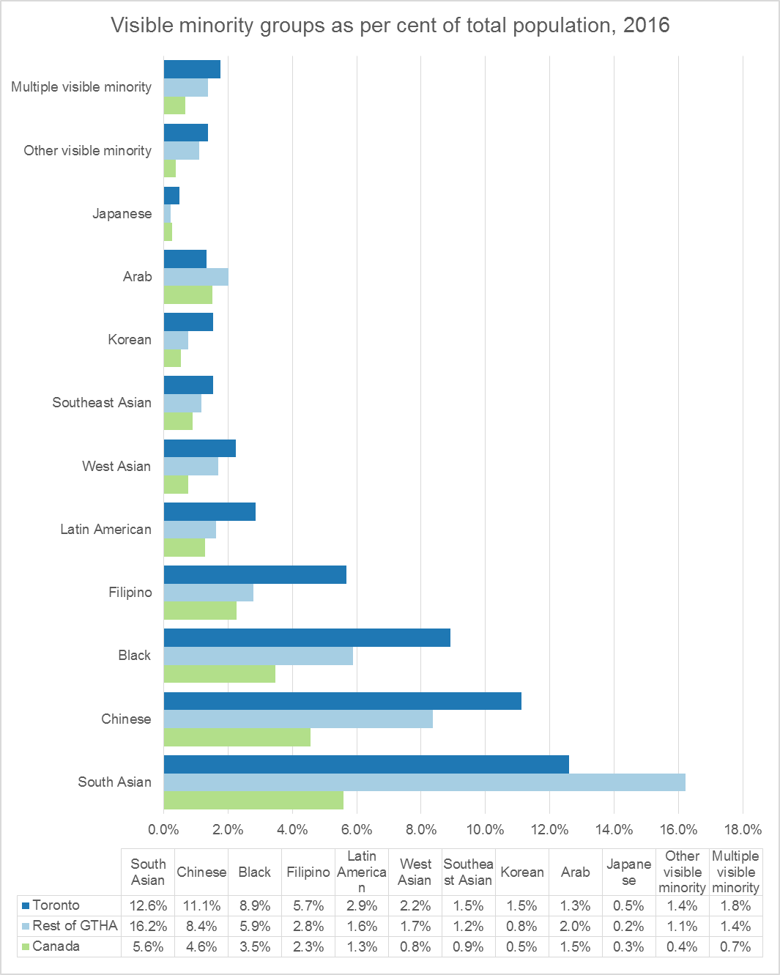
Table 2: Shelter Cost to Income Ratio, Toronto, Rest of the GTHA and GTHA, 2006 and 2016

Table 3: Shelter Cost to Income Ratio, Toronto, GTHA Municipalities, 2006 and 2016

Table 4: Total Private Households by Tenure, Toronto, GTHA and Rest of the GTHA, 2006 and 2016
Figure 6: Total Private Households by Tenure, Toronto, 1971 to 2016
Source: Statistic Canada, Censuses 1971-2016

Table 5: Total Private Households by Condominium Status, Toronto, GTHA and Rest of the GTHA, 2016

Table 6: Total Private Households by Number of Rooms, Toronto, GTHA and Rest of the GTHA, 2006 and 2016

Table 7: Total Private Households by Number of Bedrooms, Toronto, GTHA and Rest of the GTHA, 2006 and 2016

Table 8: Total Private Households by Period of Construction, Toronto, GTHA and Rest of the GTHA, 2016
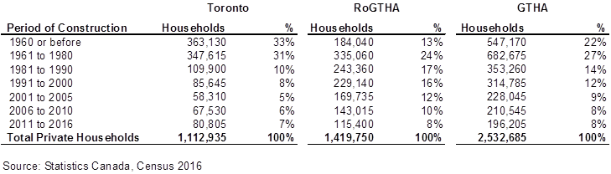

Table 9: Total Private Households by Tenure by Age of Primary Household Maintainer, Toronto, 2016

Figure 7: Age of Primary Household Maintainer by Tenure and the GTHA Municipalities, 2016

Source: Statistics Canada, Census 2016

Figure 8: Average Dwelling Value Reported by Homeowners in the GTHA, 2016

Source: Statistics Canada, Census 2016

Map 1: Dwelling Units Constructed Between 2011 and 2016, Toronto
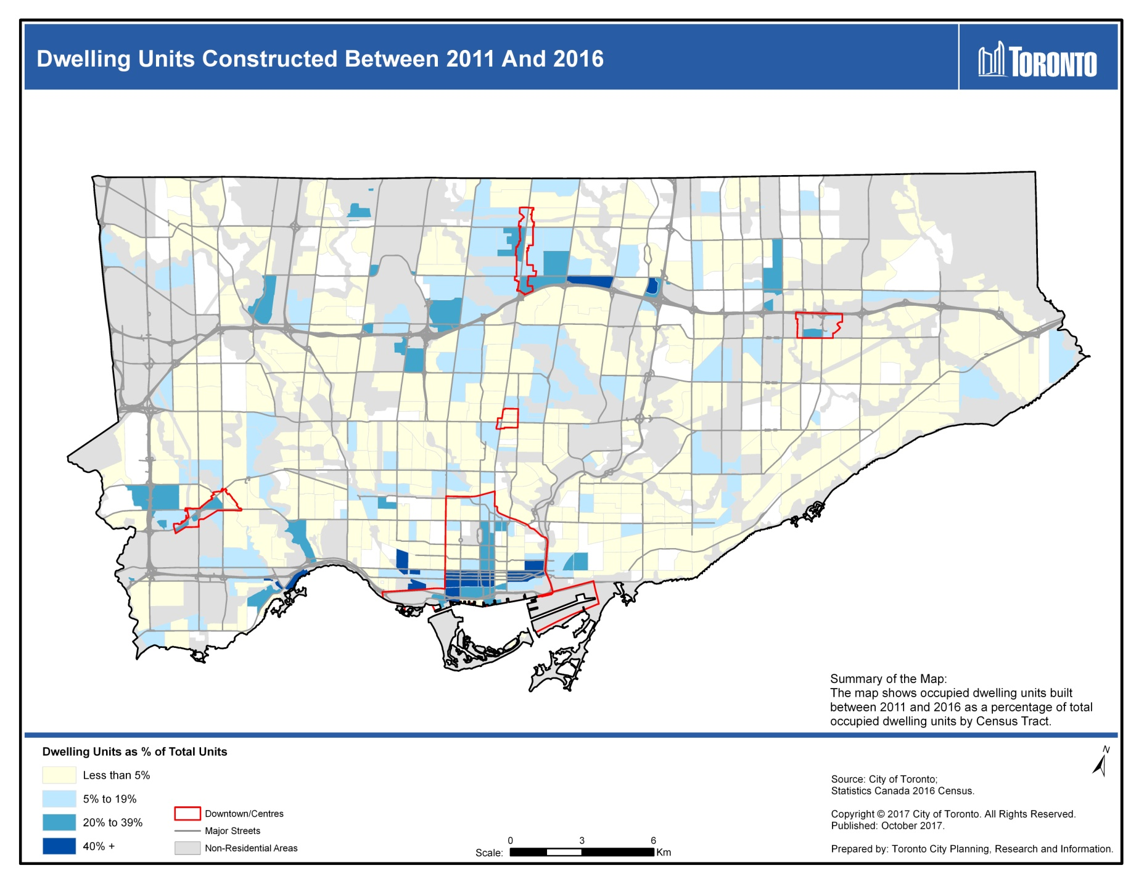
Map 2: Tenant Household Shelter Costs, Toronto, 2016
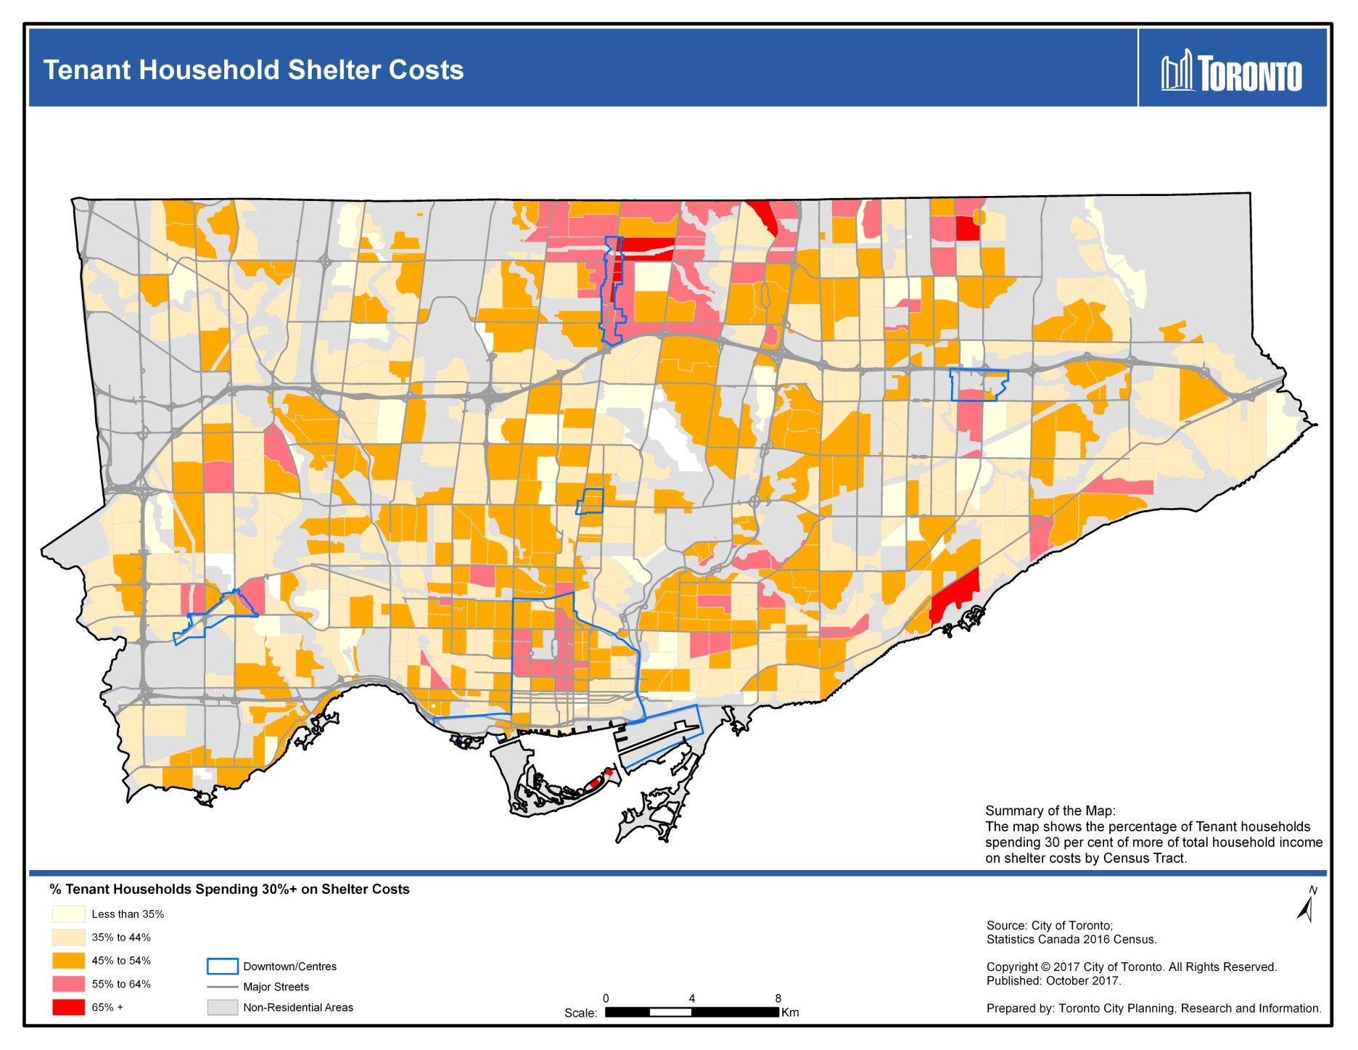
Map 3: Population of immigrants admitted as refugees (1980-2016), Toronto 2016
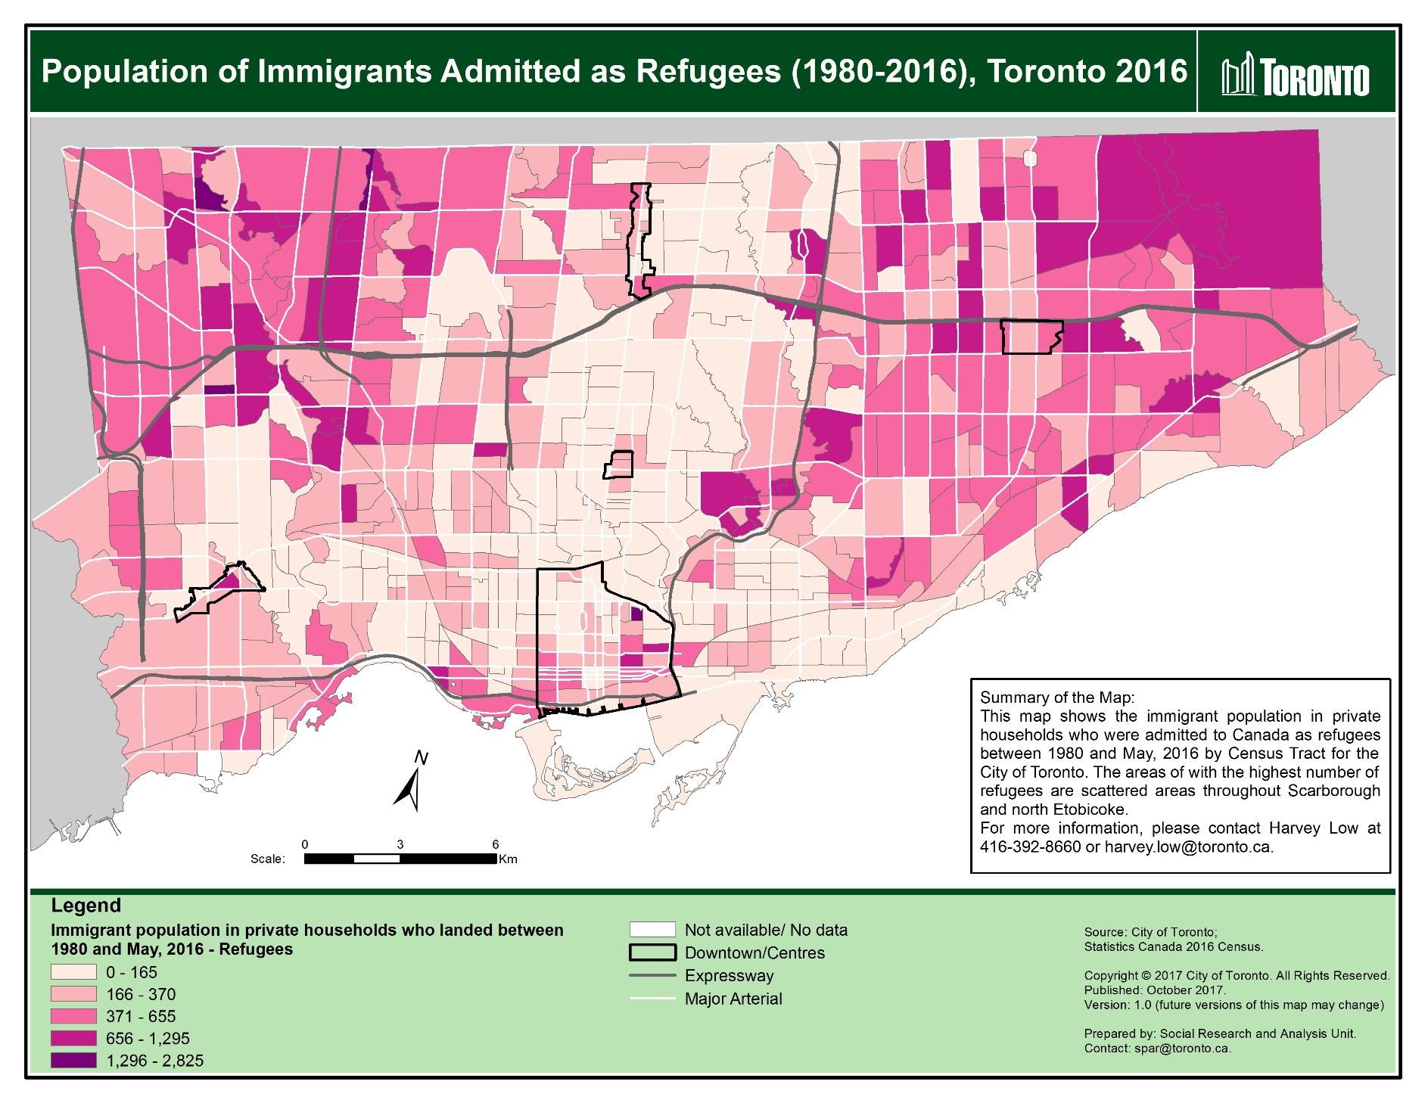

Map 4: Population of immigrants admitted as refugees (1980-2016), GTHA municipalities, 2016
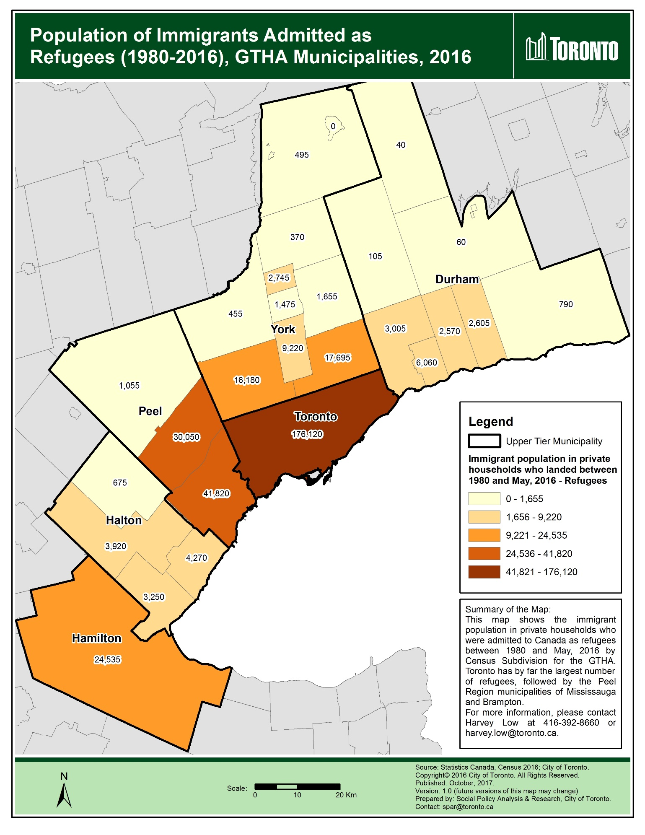

Map 5: Population of immigrants admitted as economic immigrants (1980-2016), Toronto 2016
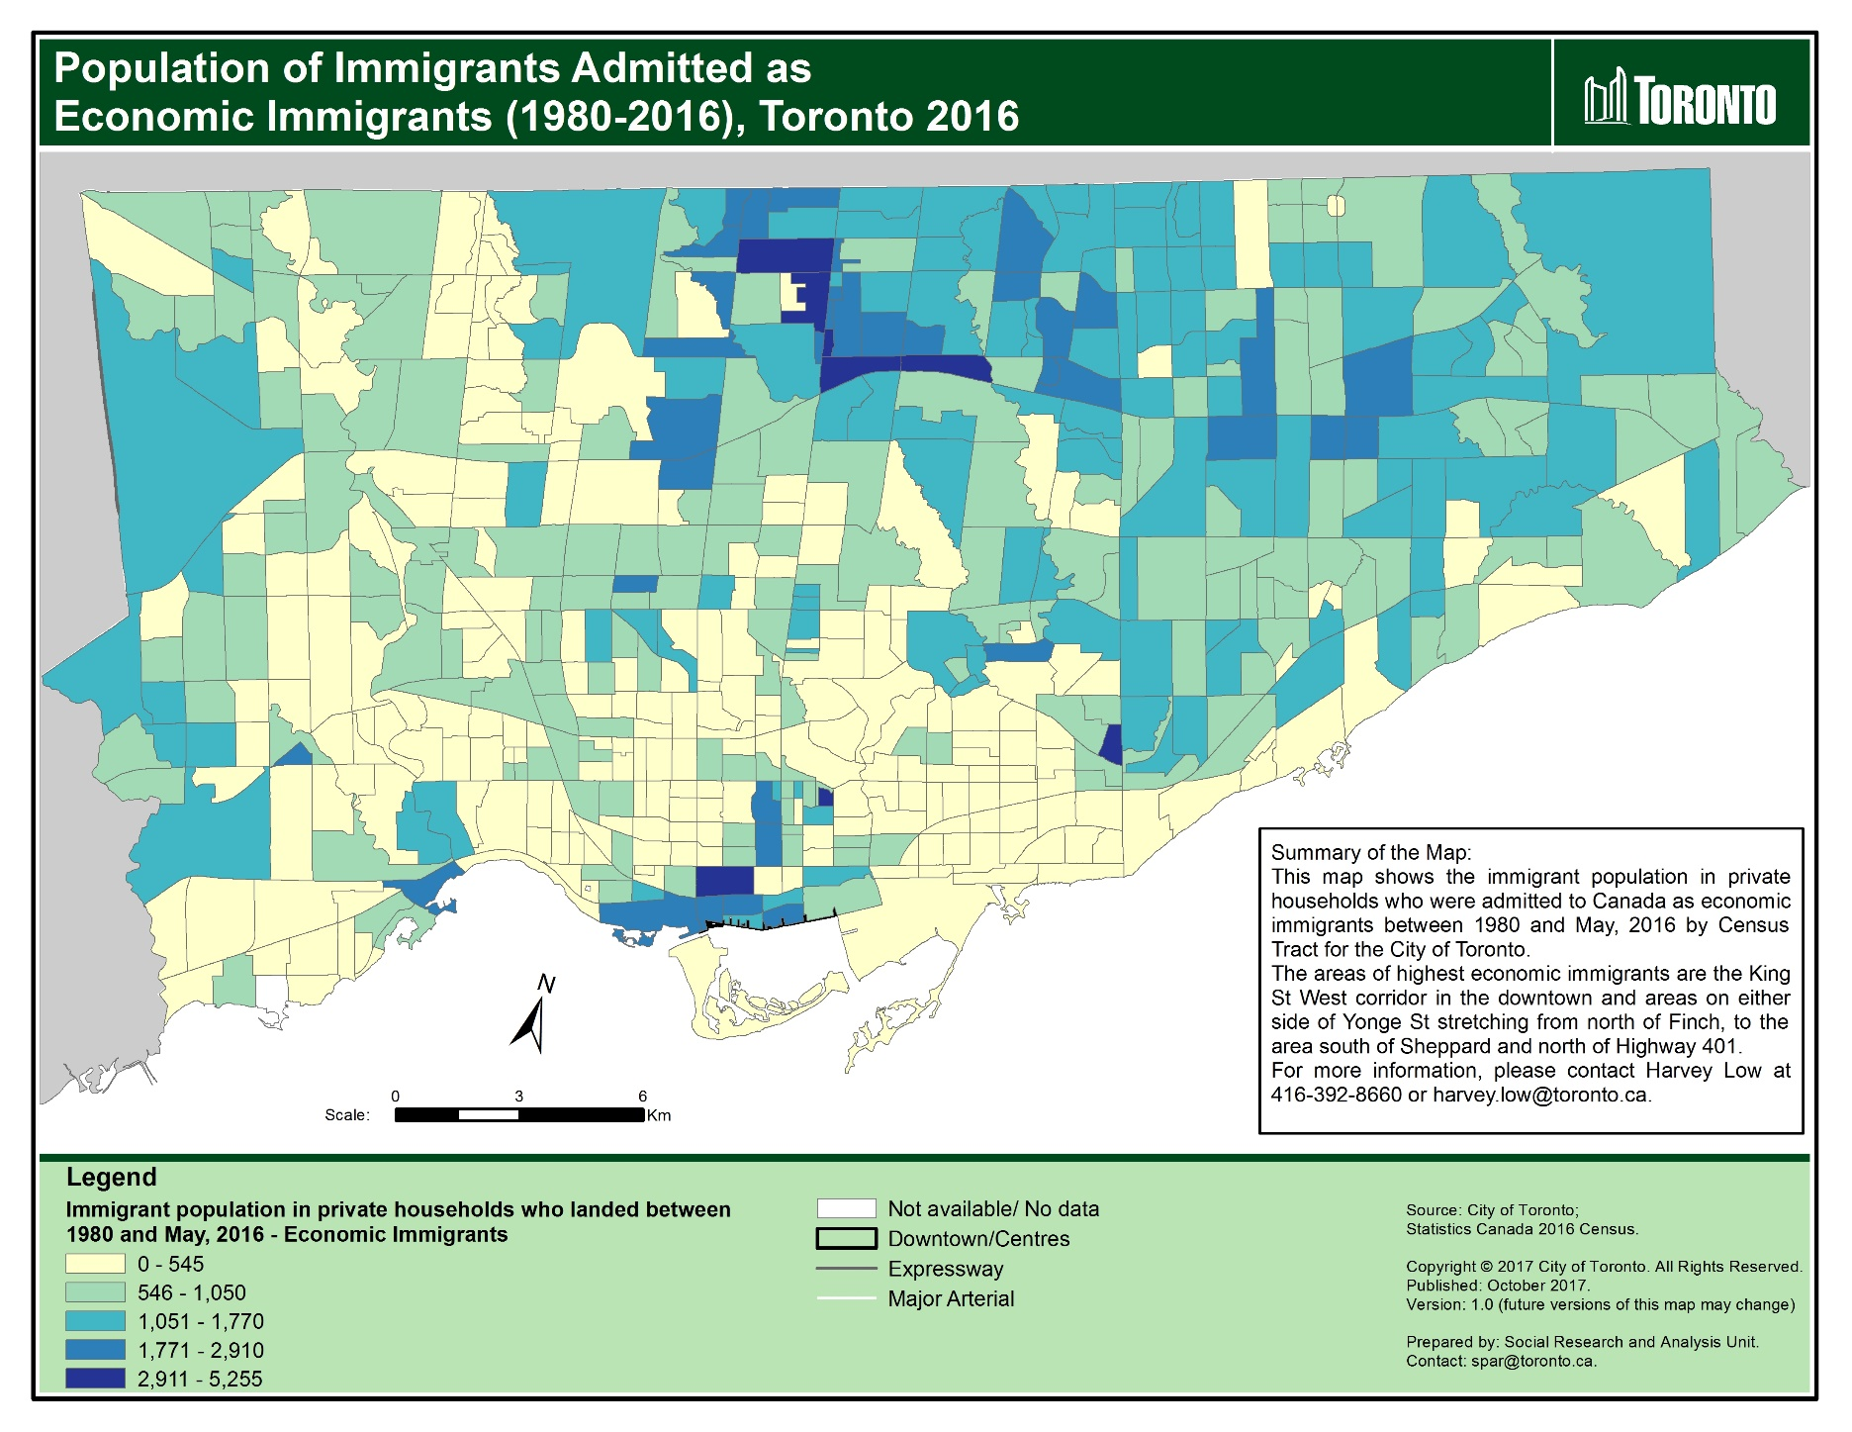

Map 6: Population of immigrants admitted as economic immigrants (1980-2016), GTHA municipalities, 2016
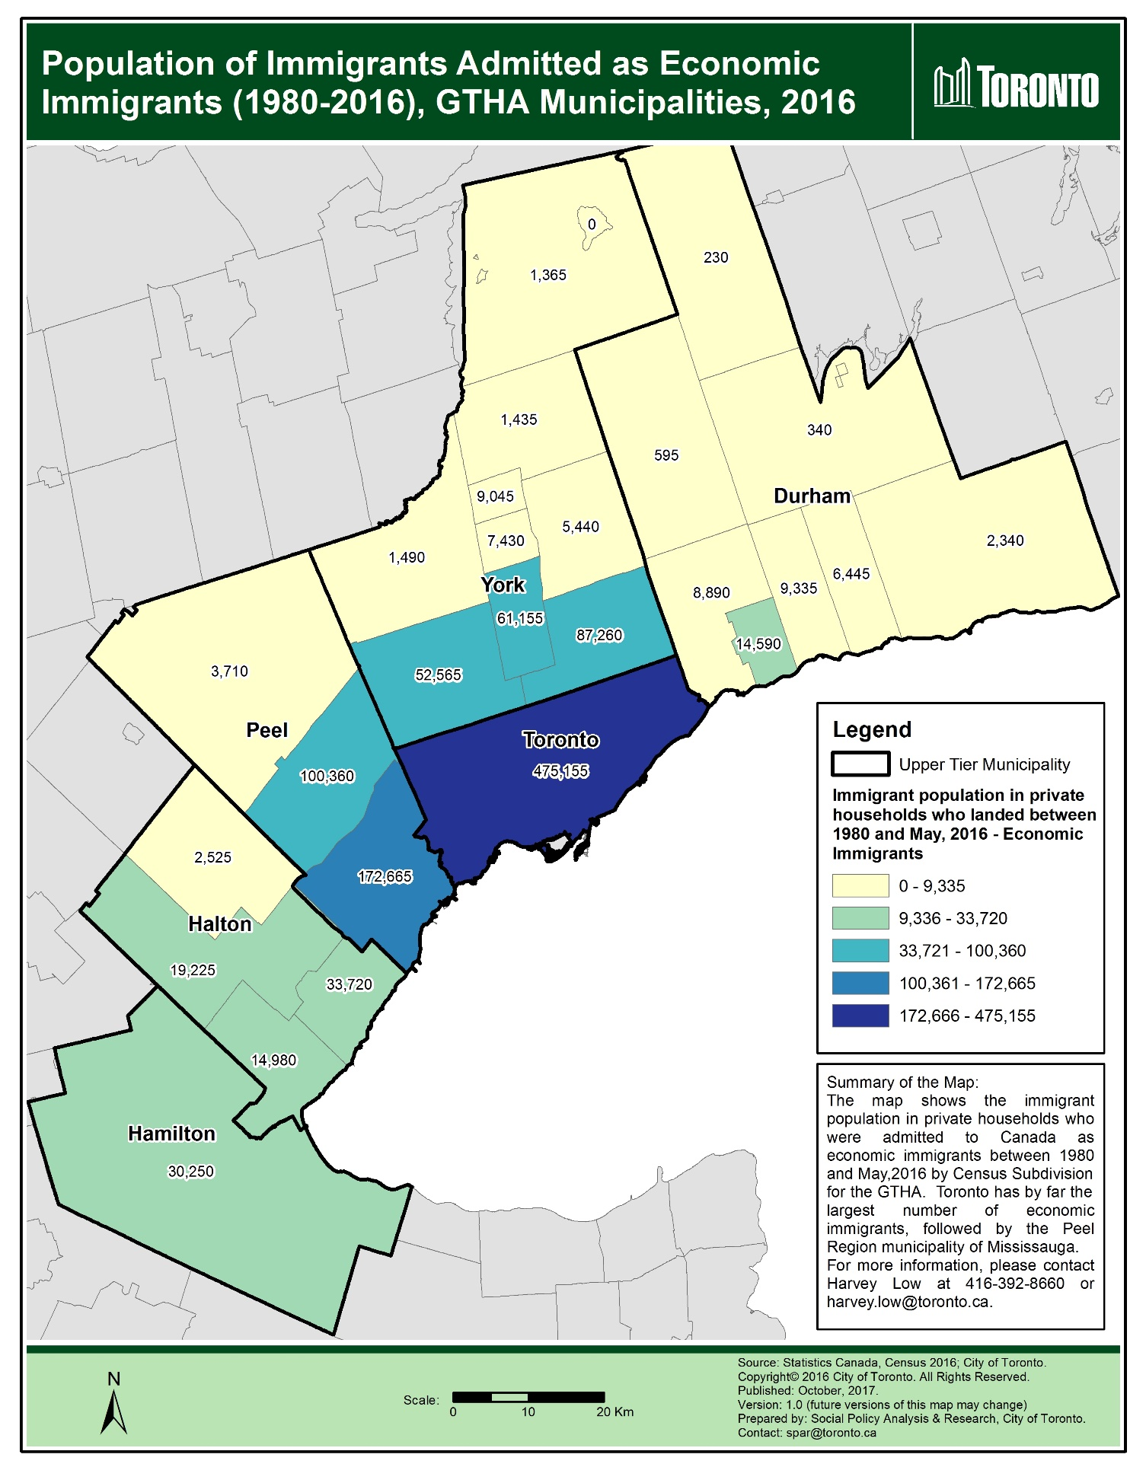

Map 7: Proportion of population who are members of a visible minority group, Toronto, 2016
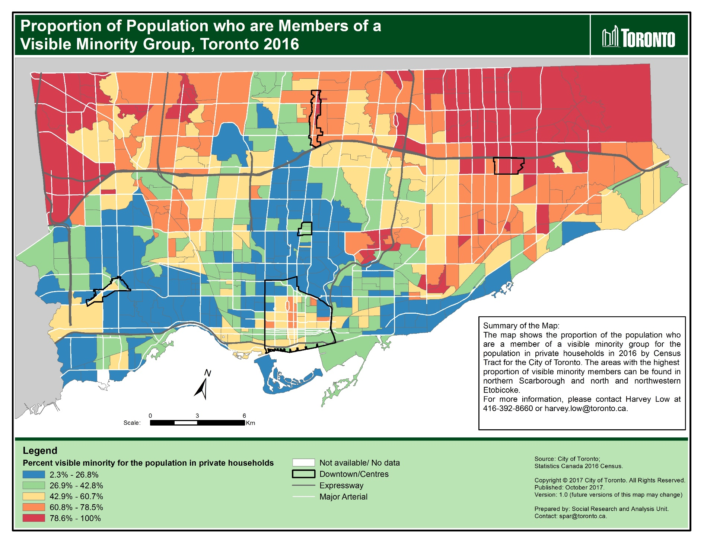

Map 8: Proportion of population who are members of a visible minority group, GTHA municipalities, 2016
